Project Design Phase
Problem – Solution Fit Template

Date | 27 August 2026
Project Name | Employee Raise Issue
Maximum Marks | 2 Marks

Problem – Solution Fit Template
The Problem–Solution Fit for the Employee Raise Issue system focuses on identifying the difficulties employees face when reporting workplace issues and ensuring that the proposed solution effectively addresses those difficulties. The system provides a structured platform where employees can raise issues, track their progress, communicate with HR/Admin, and receive timely updates until the issue is resolved.

Purpose:
❑ Identify employee problems related to reporting and resolving workplace issues.
❑ Provide a simple and centralized platform for employees to raise their concerns instead of depending on emails, phone calls, or verbal communication.
❑ Improve issue tracking and transparency by allowing employees to see the current status of their reported issues.
❑ Reduce delays and miscommunication by automatically assigning issues to the appropriate HR/Admin or concerned department.
❑ Improve employee satisfaction by providing timely notifications, resolution details, and feedback options.
❑ Help HR/Admin manage issues efficiently through a centralized dashboard and issue-management system.
❑ Understand the existing situation in order to improve the issue-reporting and resolution process for employees.
Template:
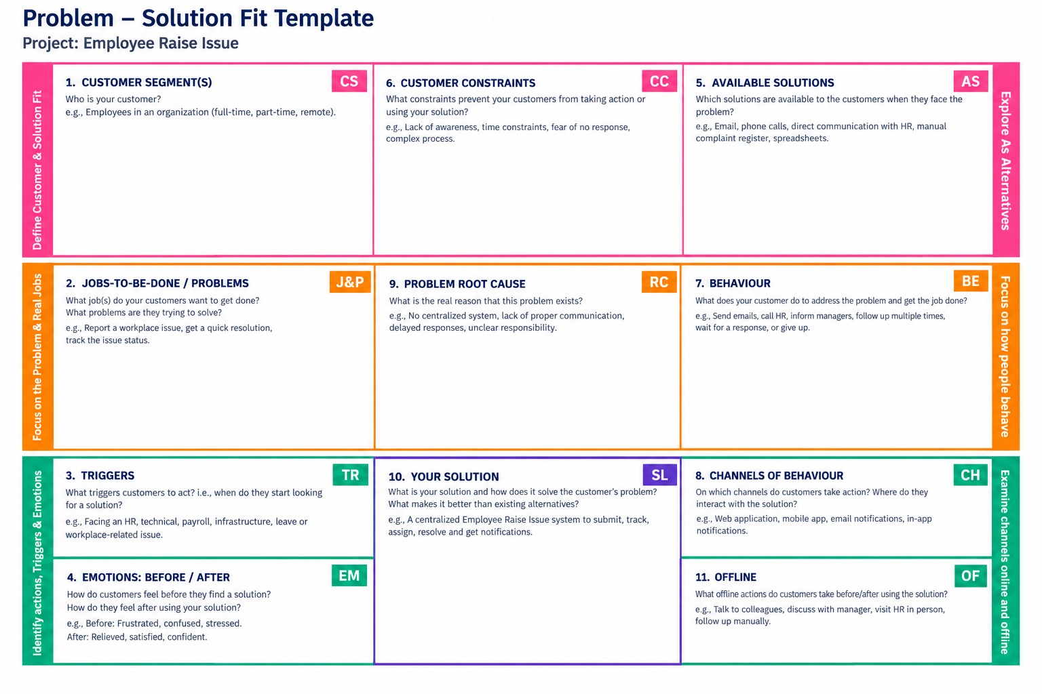
References:
- https://www.ideahackers.network/problem-solution-fit-canvas?utm_source=chatgpt.com

